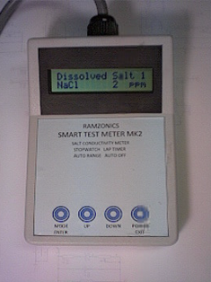

**Features**

* Displays Dissolved Salt (temperature compensated) in ppm
* Displays Resistivity in Ω/cm Compensated to 25°C
* Displays Resistivity in Ω/cm at Solution Temperature
* Displays Conductivity in µS/cm Compensated to 25°C
* Displays Total Dissolved Solids ppm TDS
* Displays Water Temperature in °C
* Stopwatch, Lap Timer (new in Mk2)(disables auto off function)
* Auto Range
* Auto Off (user adjustable, New in Mk2)
* Probe connected with 1m cable
* Compared to the original Ramzonics salt meter the Mk 2 is:
  + 5 times faster reading,
  + Double the accuracy and
  + 2.5 times more range that the original meter.Can measure 2ppm to 80,000ppm (Dead Sea)
  + Suitable for educational use.
* “Oops” factory restore function.

**Specifications & Calibration**

**Specifications**

* Salt Solution Absolute Zero Value +/- 20 ppm.
* Salt Solution Scale Value Reference Calibration Value (10,000)
* For Solutions of 1,000, 2,000, 5,000, 10,000, 20,000, 50,000 ppm
* +/- 3% of Reading. (D/A, A/D Converter errors).
* Temperature
* Absolute Temperature Factory Calibrated to +/- 0.2 at 25°C.
* Scale factor +/- 2% -20°C to +120°C
* Stopwatch Function
* Unadjusted Frequency Tolerance:± 0.5%; Frequency Stability:± 0.2% (+/- 25 seconds per Hour)
* Operating Temperature Range:-20°C to +80°C

**Menu Flowchart**

**For Salt Solution 5gm NaCl per Litre**